

**K J Somaiya College of Engineering, Mumbai-77**

**(Autonomous College Affiliated to University of Mumbai)**

Batch: Roll No.: 16010221038

Experiment / assignment / tutorial No.__6__

Grade: AA / AB / BB / BC / CC / CD /DD

Signature of the Staff In-charge with date

**Title**:Coplanar Concurrent Force System

**CO3** Analyze applications of equilibrium using free body diagram

**Objective**

To verify the condition of equilibrium of a coplanar concurrent forces .

**Theory**

Resultant of a force system is a force or a couple that will have the same effect to the body, both in translation and rotation, if all the forces are removed and replaced by the resultant.

**Resultant of Coplanar Concurrent Force System**

The lines of action of each force in coplanar concurrent force system are on the same plane. All of these forces meet at a common point, thus concurrent. In x-y plane, the resultant can be found by the following formulas:

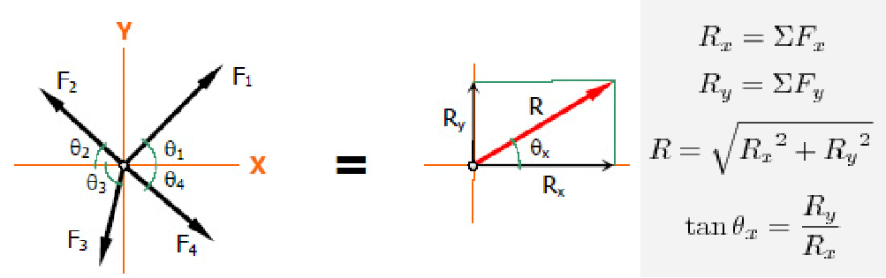

**AIM:**

To verify the condition of equilibrium of a coplanar concurrent system of forces and analyse the error if any.

**Department of Mechanical Engineering**



**K J Somaiya College of Engineering, Mumbai-77**

**(Autonomous College Affiliated to University of Mumbai)**

**APPARATUS:**

Universal force table, Weights and Spirit level.

**Setup Diagram:**

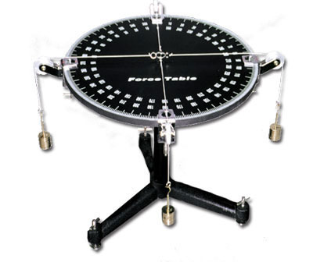

**PROCEDURE:**

1. Place the Universal force table on the firm platform.
2. Make the circular disc in horizontal position with the help of foot screws.
3. Put slotted weights to each hanger to these ends of strings passing over the pulleys.
4. Note the sum of slotted weights in each hanger and weight of hangers as five forces F1, F2,F3,F4 and F5.
5. Measure the angles included between the two adjacent pulleys and note them as Ө1 to Ө5.
6. Record these observations.

**Department of Mechanical Engineering**



**K J Somaiya College of Engineering, Mumbai-77**

**(Autonomous College Affiliated to University of Mumbai)**

1. Repeat by changing any one or two pulley positions and take three sets of readings.
2. Draw force polygon.

**OBSERVATION TABLE:**

|  |  |  |  |  |  |  |  |  |  |  |  |  |  |
| --- | --- | --- | --- | --- | --- | --- | --- | --- | --- | --- | --- | --- | --- |
| **Sr** | **Forces** | | | |  | **Angles** | |  |  |  |  | **∑Fx** | **∑Fy** |
| **No** |  |  |  |  |  |  |  |  |  |  |  |  |  |
|  | **F1** | **F2** | **F3** | **F4** | **F5** | **Ө1** |  | **Ө2** | **Ө3** | **Ө4** | **Ө5** |  |  |
|  |  |  |  |  |  |  |  |  |  |  |  |  |  |
| **1** | 3.43 | 1.96 | 3.43 | 2.94 | 2.45 | 0 | 6 | 5 | 142 | 213 | 292 |  |  |
|  |  |  |  |  |  |  |  |  |  |  |  | 0.007 | 0.015 |
| **2** | 2.5 | 2 | 2.5 | 2.5 | 3 | 0 |  | 65 | 129 | 199 | 280 |  |  |
|  |  |  |  |  |  |  |  |  |  |  |  | -0.071 | -0.012 |
| **3** | 2.5 | 2 | 2.5 | 3 | 2 | 0 |  | 65 | 143 | 214 | 292 | -0.389 | -0.215 |
|  |  |  |  |  |  |  |  |  |  |  |  |  |  |

**CALCULATION:**

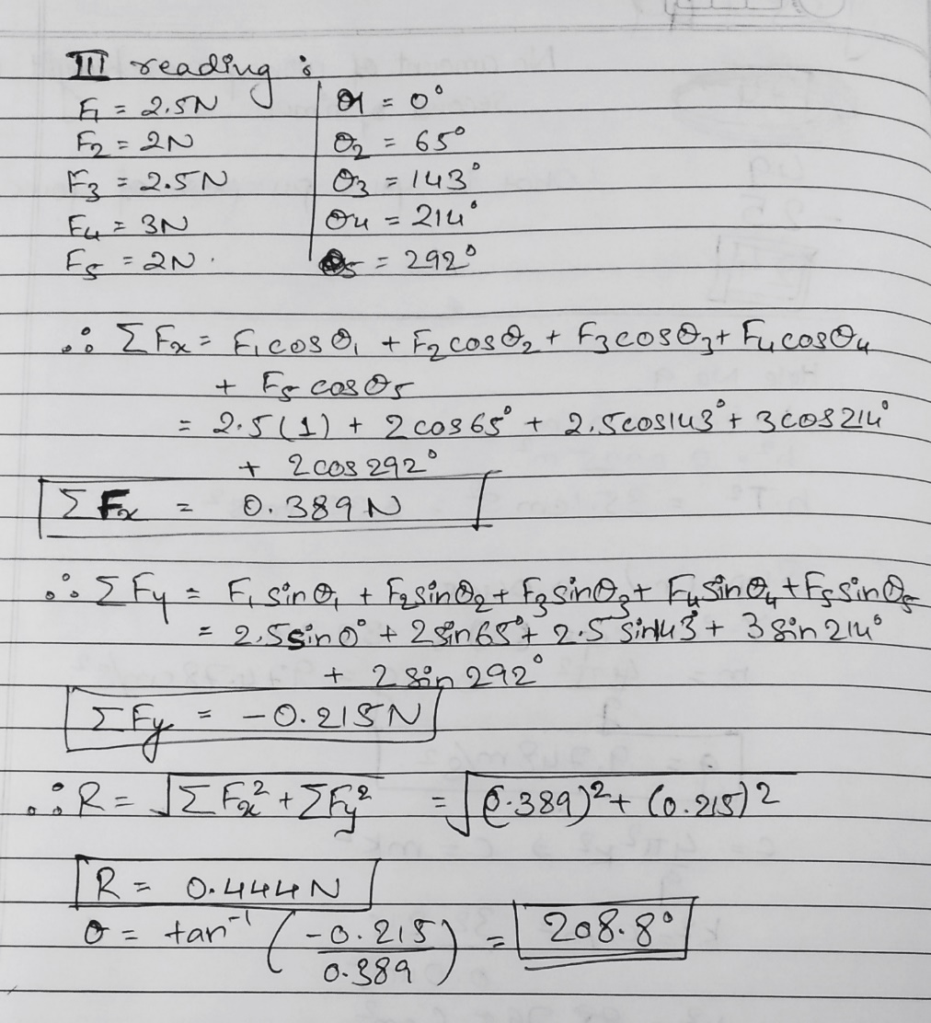

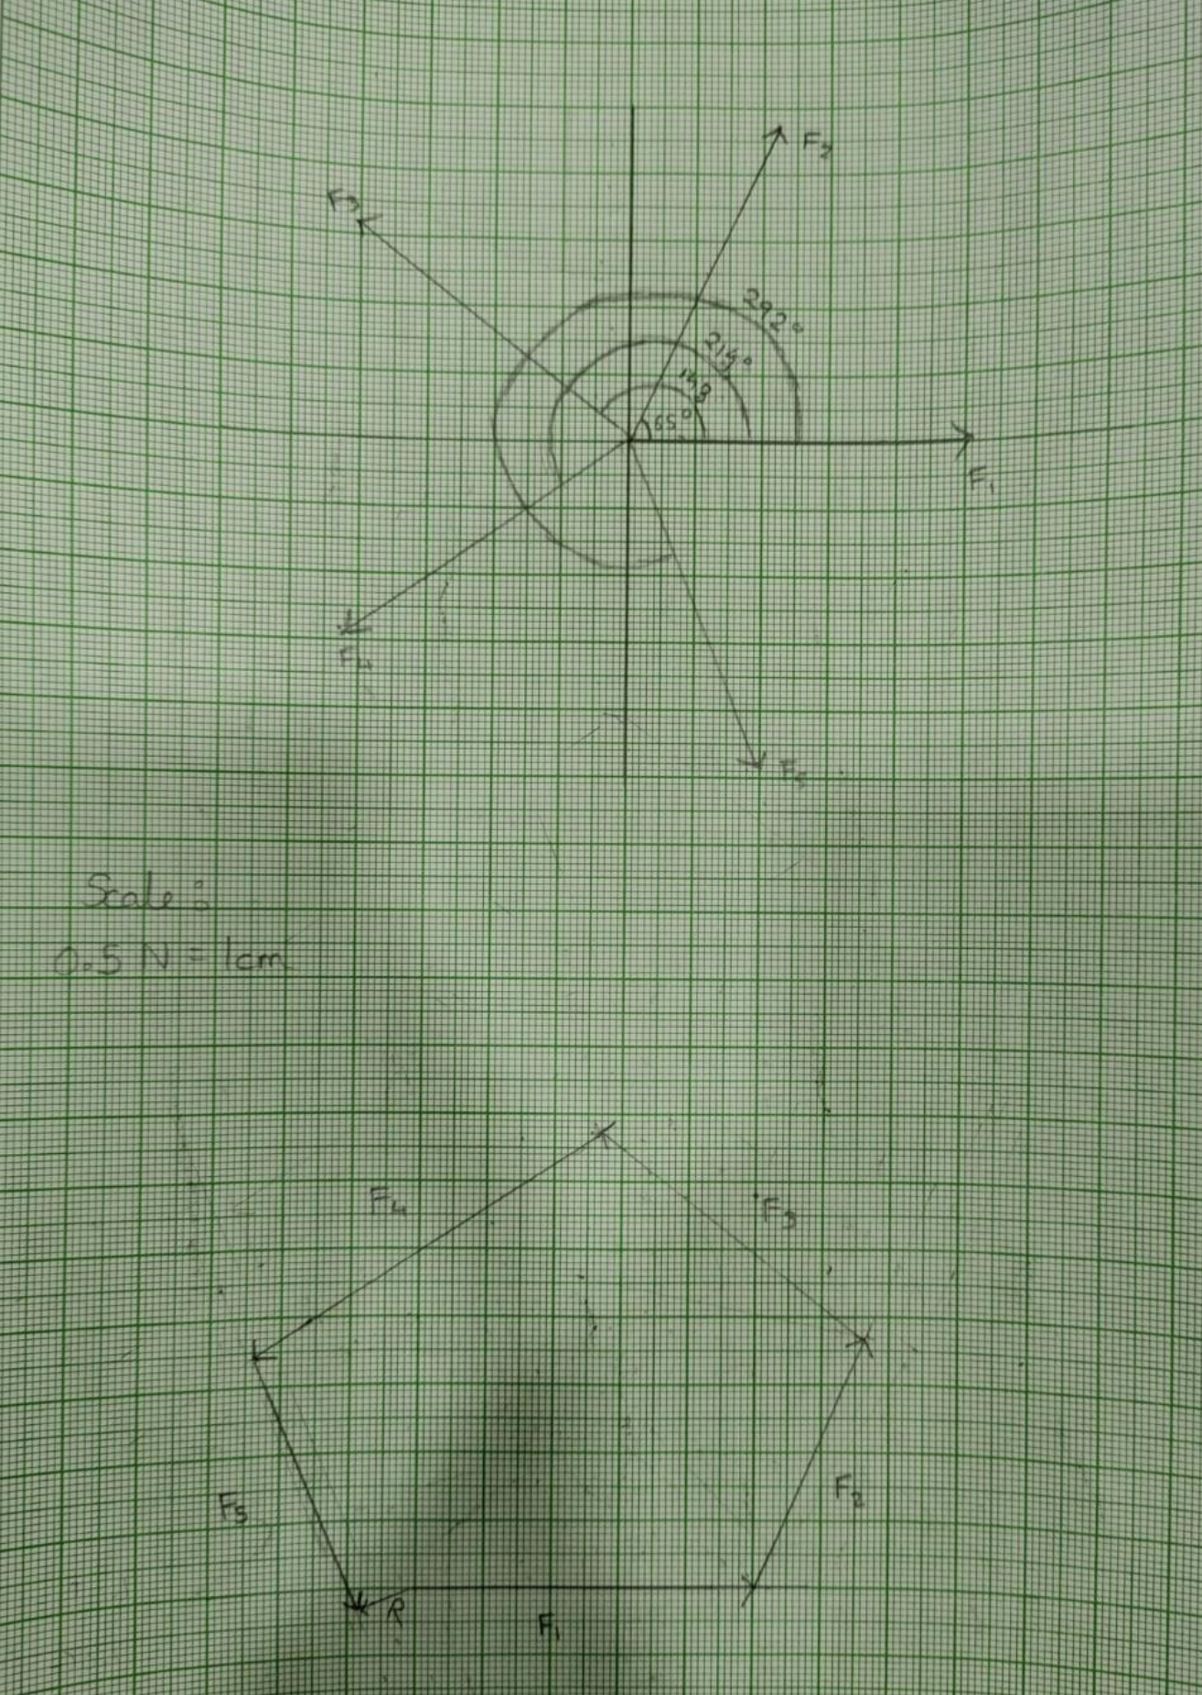

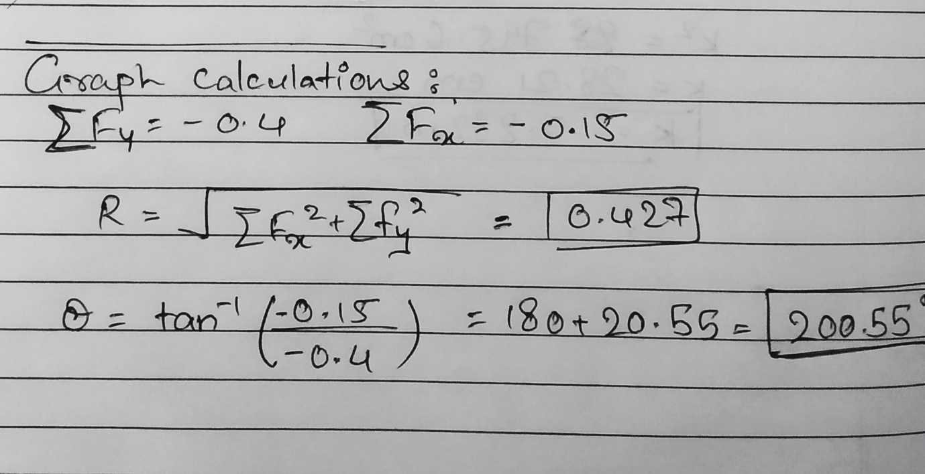

**RESULT:**

**For Set 3:**

**Analytical Results:**

ΣFx= -0.389 N

ΣFy= -0.215 N

R= 0.444 N

Θ= 208.8°

**Graphical Results:**

ΣFx= -0.4 N

ΣFy= -0.15 N

R= 0.427 N

Θ= 200.55

**CONCLUSION:**

We experimented the condition of equilibrium of a coplanar concurrent system of forces.

**Signature of faculty in-charge**

**Department of Mechanical Engineering**